Function Reference

File Menu
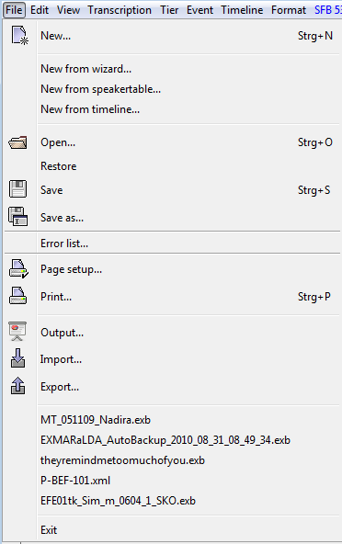

File > New...
(Shortcut: CTRL+N on Windows, ⌘+N on Mac)

Creates a new transcription. The new transcription consists of a time axis with two time points, a speaker table containing a speaker X, as well as a '"T" tier that both the speaker and the category "v"
(for "verbal") are assigned to. To change the attributes of the configured speaker, go to „File > Speakertable...“. To change other tier properties, go to "Tier > Tier properties...“. The tier contains all the standard formats. To change the format, select „Format > Format tier...“ or „Edit > Preferences...“.

File > New from wizard...
Opens an assistant to create a new transcription step by step.
The individual steps that are also explained in the assistant are:

- Creating Meta Data. If you're managing a corpus with the Corpus-Manager, the meta- data can be imported from the COMA file. The recording and speaker information of the COMA file will also be imported in the following steps.
- Assignment of Audio and/or Video Files
- Defining a Speaker
- Defining a pattern to generate tiers for every speaker.

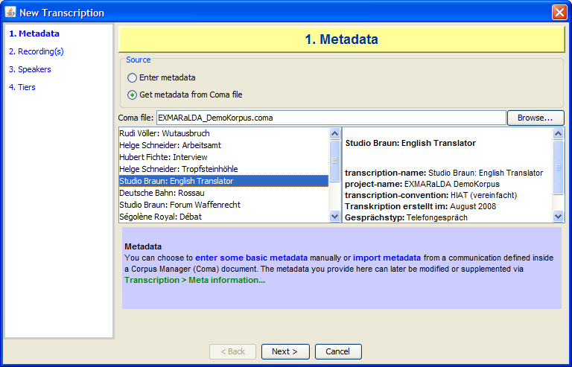

File > New from speakertable...
Generates a new transcription from a speakertable and a stylesheet (see also Appendix C). The stylesheet that is specified in the user settings (see „Edit > Preferences...“) in "Speakertable to transcription“ will be used. If there is no entry, a local stylesheet with a tier of the type "T" and the category "v" per speaker will be generated.

First, the window to edit a speakertable is displayed. Insert the desired speakers and edit their properties (see „File > Speakertable...“). The stylesheet is used by clicking OK. A new, empty musical score will be created with the tiers defined by the stylesheet.

File > New from timeline...
Opens a window, in which the timeline of a new transcription can be divided with means of an audio or video file before starting the transcription. Thus, prominent events within the recording (i.e. speaker change in interviews, change in camera settings in television productions etc.) can be inserted as time points. This can greatly simplify the transcription with certain recording types. First, you are asked to select one or more audio or video files. (see Transcription > Recordings...). Then, the following window will appear and open the previously selected audio or video file in a player.

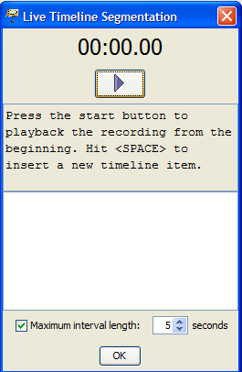

The maximum interval length for the resulting intervals can be defined via the Maximum interval length check box. E.g.,if the check box is activated, the value is set to five seconds, and you insert time points at 11.0 and 25.0 seconds, additional time points will automatically be inserted between these two time points, so that no intervals of more than 5 seconds are created. Click the start button to start playback of the recording. Then hit SPACE whenever you want to insert a new time point (i.e. at a speaker change). The list will show the time points you have inserted.

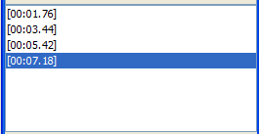

Play the recording to the end and click okay afterwards. A new, (empty) transcription will open in the editor and the timeline will contain the values you have set.

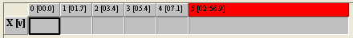

File > Open...
(Shortcut: CTRL+O on Windows, ⌘+O on Mac)

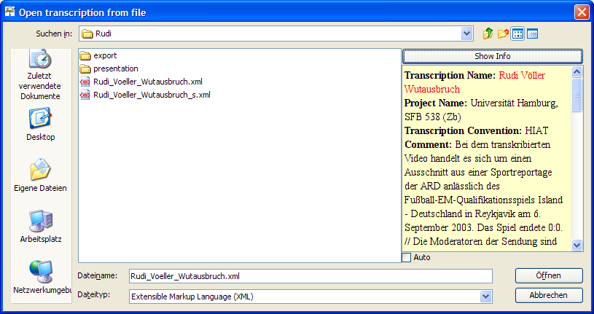

Opens a saved transcription. A standard file window of the system will be displayed, as well as all files ending in ".exb" and ".xml". Normally, the start directory is the one that was used for the last save. Additionally, information on the currently selected file can be displayed on the right. If the file is an EXMARaLDA basic transcription, its meta information will be displayed. Otherwise, a notification that states it is not an EXMARaLDA basic transcription will appear. Select "Show Info" to see information of the selected file. Activate the option "Auto" to display information for every selected file automatically.

Select the file to be opened and click "Open". Thereafter, the entire musical score needs to be formatted. For larger transcriptions this may take a few seconds. To open an associated format table, see "Format > Open format table...“.

Hint: If you would like to work on two transcriptions simultaneously, open the EXMARaLDA Partitur-Editor twice. (Do not use File > New, for the opening of a new file closes the current one.)

File > Restore
Opens the last save of the currently opened transcription. All changes since the last save will be discarded. This menu item will only be activated, if a last saved version is available.

File > Save
(Shortcut: CTRL+S on Windows, ⌘+S on Mac)

Saves the currently opened transcription under its set name. If the transcription does not have a name yet, hence the caption bar showing "untitled.exb“ the "Save as...“ window is opened automatically (see below).

File > Save as...

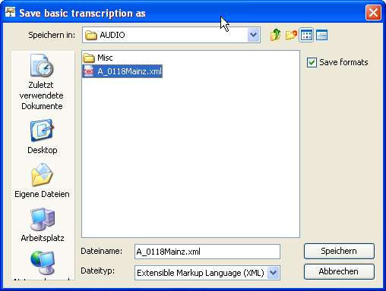

Saves the currently opened transcription under a new name. A standard file window of the system will be displayed as well as all files ending in ".exb" and ".xml". Normally, the start directory is the one that was used for the last save. Select the directory in which you would like to save the transcription, enter a name (the suffix ".exb" will be added automatically, if you do not define one) and click Save. To save the corresponding format table, activate the option "Save formats".

File > Error list...

Opens a window showing the error list.

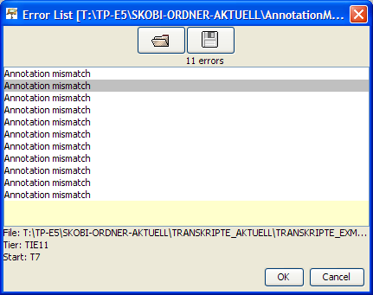

An error list is an XML file that points to specific positions in the existent transcription files. It is written by the functions "Check for segmentation errors“ and “Check for Structure Errors“ of the Corpus Manager, among others. (see the COMA documentation).

<?xml version="1.0" encoding="UTF-8"?>
<error-list>
<errors>
<error
file="ENDFAS/Bilingual/Sezen_Aksu/EFE07dt_Sez_b_0408_f_100295/EFE07dt_Sez_b_0408_2_ENF.xml"
tier="TIE16" start="T41" done="no">Annotation mismatch</error>
<error
file="ENDFAS/Mono_tk/Guznur_Bayar/Selbtk_Guz_m_0222_t_121092/Selbtk_Guz_m_0222_1_ENF.xml"
tier="TIE11" start="T7" done="no">Annotation mismatch</error>
<!-- [...] -->
</errors>
</error-list>

It can be used to comfortably edit systematic inconsistencies in the corpus, for example. Double clicking on a list entry opens the corresponding transcription, should it not be open already, and places the cursor on the position in question. Entries that have already been visited are displayed in grey instead of black.

File > Page setup…
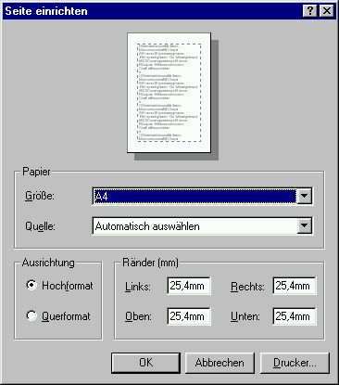

Opens a window to specify the side measurements to be used in the RTF output, or when printing. Appearance and functionality vary greatly depending on the operating system. However, they comply with the appearance of the standard window.

File > Print…
(Shortcut: CTRL+P on Windows, ⌘+P on Mac)

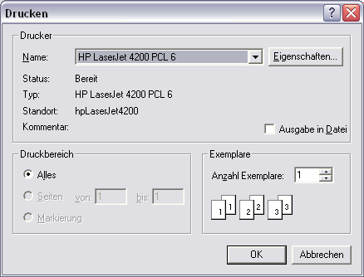

Opens a window to print the transcription. Appearance and functionality vary greatly depending on the operating system. However, they comply with the appearance of the standard window for printing.

File > Output...

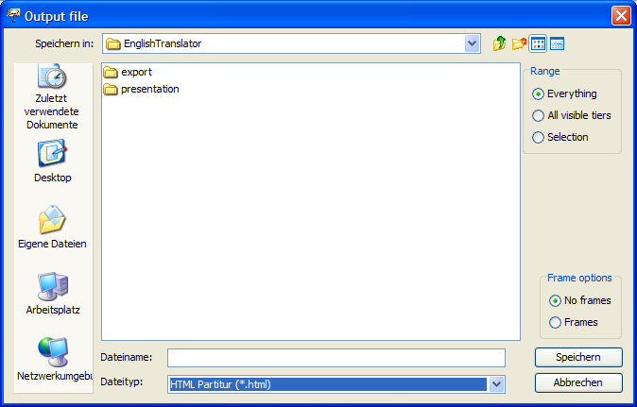

Opens a window for the output of the transcription in a presentation format, used for the display in a browser or the integration in a word processing document (i.e. MS Word).
Range allows you to define whether the output of the entire transcription is desired, or just a part of it. More specifically:
- Everything issues the entire transcription
- All visible tiers issues all visible tiers that have not been hidden via Tier > Hide Tier.
- Selection issues the current selection in the musical score.

The drop-down list Save as type offers different formats:

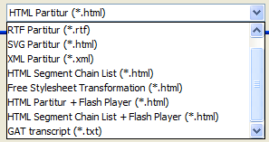

1. HTML musical score: Select the directory in which you would like to save the HTML output and enter a name (the suffix „.html“ will be added automatically, if you do not define one). Select "Frames“, if you would like the transcription's existing links to be realised as hyperlinks in a separate frame. Select "No frames“ if the transcription does not contain links, or if the hyperlinks should be opened in a new window. Then click "save“ to implement the output. Thereafter, the file can be opened in any browser. The meta information and speaker table output can be parametrised via Edit > Preferences > Stylesheets as „Head to HTML“. See Appendix C: "EXMARaLDA and Stylesheets”.

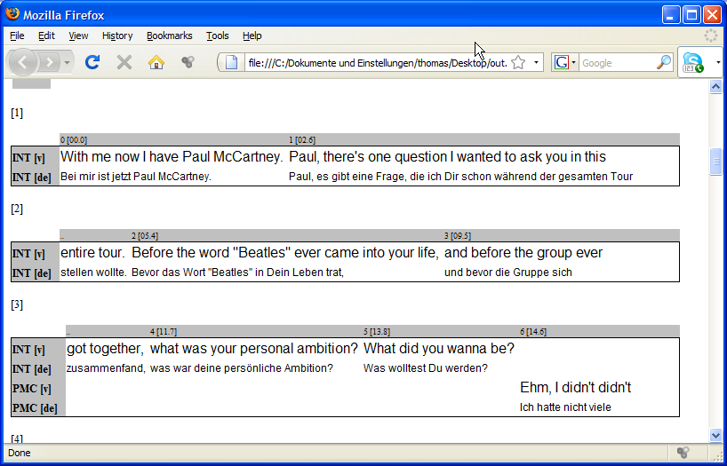

1. RTF musical score: Select the directory in which you would like to save the RTF output and enter a name (the suffix ".rtf“ will be added automatically, if you do not define one). Then click "save“ to implement the output. Thereafter, the file can be opened and edited in any word processor that can read RTF files (especially MS Word).

3. SVG musical score: SVG means "Scalable Vector Graphics“ and is an XML based format to describe vector graphics. Vector graphics can be edited in graphic software (i.e. Corel Draw, Adobe Illustrator). Furthermore they can be used as high quality print templates, due to the fact that scaling does not damage sharpness or definition. Thus, they are probably the best solution to integrate musical scores into printed publications.

If the Partitur-Editor creates SVG files from a transcription, it writes an SVG file for every musical score area that has been created due to a line break. These are saved in a shared directory and compiled in a superordinate HTML file that refers to the SVG files in such a way that they can be viewed with a browser that is capable of displaying SVG files.

When choosing this output option, the following panel is shown on the side of the file dialogue:

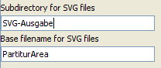

In it, the parameters for the output can be set:
Subdirectory for SVG files: sets the name for the directory in which the SVG files are supposed to be saved. This directory will be created in the same folder as the superordinate HTML file, if it is not available yet.
Base filename for SVG files: sets the base file name for the SVG files. The full name of an SVG file then consist of this base file name, followed by the number of the musical score area, followed by the suffix ".svg".

The above mentioned settings create files and directories such as:

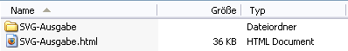 | 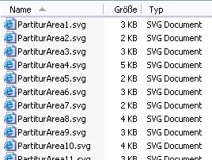

The file “SVG-output.html“ can be opened with any browser (e. g. Internet Explorer, Firefox) that possesses a suitable SVG plug-in (e. g. of Adobe or Corel). However, you can also open the individual SVG files with a suitable software (e. g. Adobe Illustrator) and edit them or save them in a different graphic format (e. g. WMF, which can be pasted into a Word document), if desired.

- XML musical score: This option creates an XML coded version of the musical score representation ("Interlinear Text") of the current transcription. The settings chosen under "File > Partitur parameters…" and those of the current format table (see also "Format > Edit format table…") will be used. The XML coding is compliant with the DTD (“interlinear-text.dtd“). The current version is available in the download area of the EXMARaLDA Homepage. We assume that this function is not of interest to most users. It is intended for users that plan on developing their own visualisation (containing XSL stylesheets and the like).

5. HTML Segment Chain List: This option creates an HTML file in which the speaker contribution is organised in a segment chain list. Segment chains are defined as interrelated events in a transcription tier. This form of output is similar to the classic line notation used in conversation analysis, in theatre scripts or in printed interviews, among others.

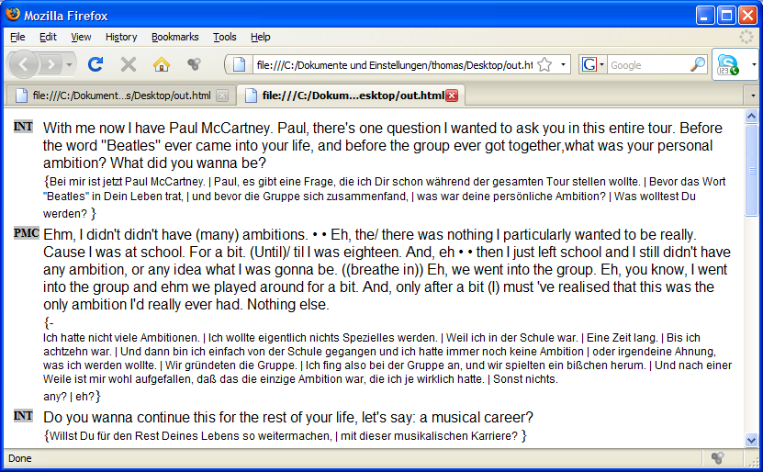

6. Free Stylesheet Transformation: Uses a stylesheet on a transcription (see also Appendix D). Uses the stylesheet that is selected via ”Edit > Preferences“ in the tab “Stylesheets“ under “Free stylesheet visualisation“.

7. HTML Partitur + Flash Player: This option creates an HTML musical score (as in option 1). In addition, it integrates a Flash Player that allows sections of the recording to be played by clicking on them.

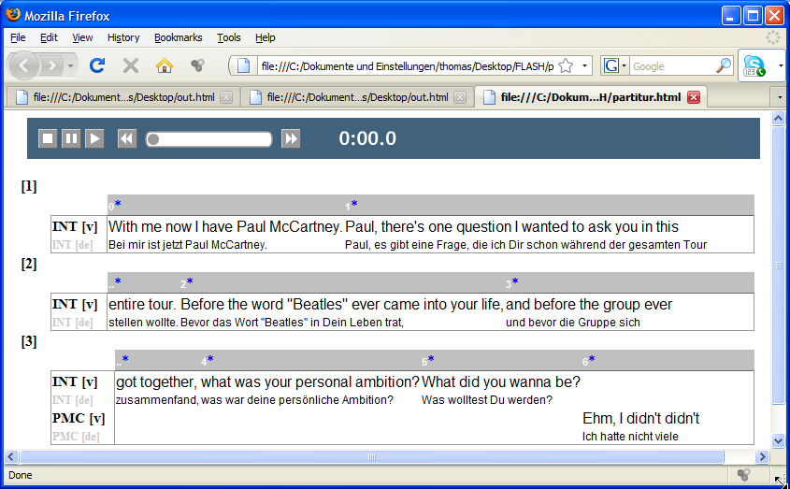

Requirements for the use of this option are:

1) that the transcription is linked to an MP3 file (via Transcription > Recordings...). Other audio or video recordings will not be played by the Flash Player. If there is no link to an MP3 file, an error message will appear and the HTML musical score will not be created.

2) that the transcription is at least partially aligned. Hence, some time points on the time axis need to be equipped with absolute time values that refer to the recording.

Take note that this option creates three additional files in the same directory, in addition to the HTML file that contains the musical score:

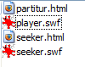
The files "player.swf" and "seeker.swf" are Flash applications that serve the purpose of playing the recording. The file "seeker.html" is designed to integrate the Flash components into the musical score.

8. HTML Segment Chain List + Flash Player: This option creates an HTML segment chain list (as in option 5). In addition, it integrates a Flash Player that allows sections of the recording to be played by clicking on them.

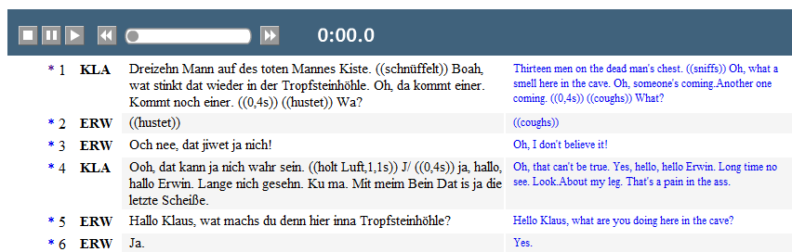

For further explanation, see 7.

9. GAT Transcript: exports a text file with a layout similar to the layout specifications of GAT (Gesprächsanalytisches Transkriptionssystem GAT, Selting et al. 1998).

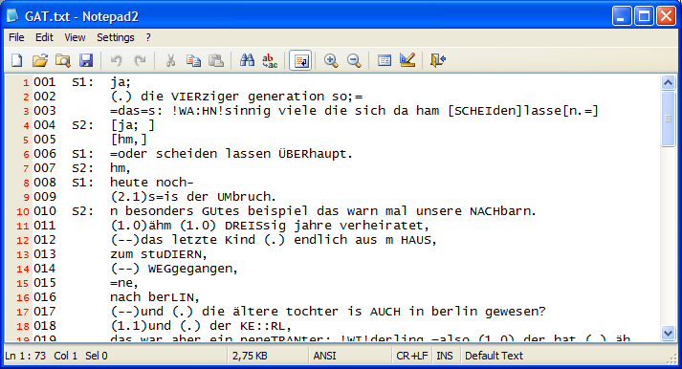

Requirement for this output option is that the transcription can be segmented with the GAT segmentation algorithm, i.e. the GAT transcription symbols have been used according to convention (see also Appendix B: Segmentation Algorithms). If segmentation errors have been made, an error message will appear and no output file will be created.

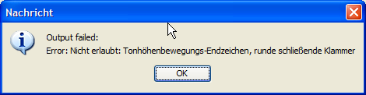

8. HTML Partitur + HTML5 Audio: This option creates an HTML musical score (as in option 1). In addition, it integrates an HTML5 Audio Player that allows sections of the recording to be played by clicking on them.

9. HTML Segment chain list + HTML5 Audio: This option creates an HTML segment chain list (as in option 5). In addition, it integrates an HTML 5 Audio Player that allows sections of the recording to be played by clicking on them.

File > Import
Opens a window to import in other formats. The drop-down list "Save as type" offers different formats:

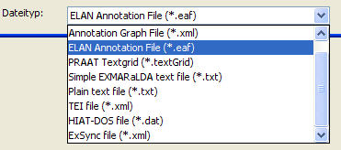

1. TASX Annotation File: Imports a file in TASX-Format. After the import, a window to clean the transcription up is displayed (see "Transcription > Cleanup..."). Under certain circumstances, this window is displayed thereafter:

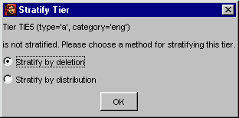

This dialogue states that some tiers contain events that overlap each other within the tier ("the tier is not stratified“). In order to display transcriptions as a musical score, overlapping events within a tier may not exist. Choose one of the following options:

  - Stratify by deletion: deletes one (the second) of two overlapping events
  - Stratify by distribution: distributes one (the second) of two overlapping events into a new tier.

Thereafter, it will appear in the musical score in the editor.

2. Annotation Graph File: Imports a file in the ATLAS-Interchange-Format, Level 0. The format can be used as an exchange format with a number of other tools (ANVIL, Transformer, MAVVissta, etc.). For this, see:

Th. Schmidt, S. Duncan, O. Ehmer, J. Hoyt, M. Kipp, D. Loehr, M. Magnusson, T. Rose & H. Sloetjes (2008): An exchange format for multimodal annotations. In: Proceedings of the Language Resource and Evalutation Conference 2008, Marrakech, Paris: ELRA.

3. ELAN Annotation File: imports a transcription created in ELAN (EUDICO Linguistic Annotator). Select the file to be imported and click Open (normally the file ending is “.eaf”). After the conversion a "Cleanup-Dialogue“ will allow you to clean the transcription up according to certain criteria (see "Transcription > Cleanup “). Thereafter, the transcription will appear as a musical score in the editor.

4. FOLKER Transcription: imports a transcription created in FOLKER (the FOLK-Editor of the IDS Mannheim).

5. Winpitch file: imports a file created with the Winpitch software (http://www.winpitch.com/)

6. Transcriber file: imports a file created with the Transcriber software (http://trans.sourceforge.net/en/presentation.php).

7. Praat Textgrid: Imports a transcription created in Praat. Select the TextGrid you would like to import and click Open. Thereafter, the transcription will appear as a musical score in the editor. Take note that the editor expects a "regular" TextGrid for the import, and not a "short“ TextGrid.

8. Simple EXMARaLDA text file: A Simple EXMARaLDA file is a transcription in txt-format that has been created according to the "Simple EXMARaLDA“ specifications. You can find these specifications in Appendix A. If you have created a transcription according to these specifications in a text editor or a word processing software and saved it as "pure text" (either coded as Unicode or a standard coding specified by the system), you can import a text file to the Partitur-Editor. For this, search for the file and select the suitable coding in the drop-down list on the side. Then click "Open“.

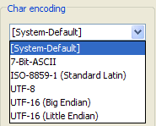

If the import is successful, a musical score representation will be visible in the transcription. If the import fails, an error message of the following kind will appear:

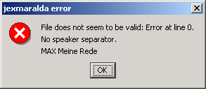

The first line contains the line number of the original file, in which the error occurred. The second line contains the type of error. (here: "no speaker separator“, hence the speaker abbreviation was not ended in a colon) and the third line presents the entire line containing the error. Open the text file in a text editor, fix the error, save the file and reattempt the file import.

9. Plain text file: imports any text file into a single tier in the musical score. The window presents options as to according to which rule the content of the text file will be distributed into the events of the tier:

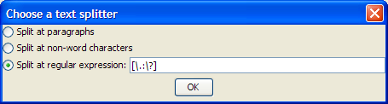

This is exemplified in the following text file example:

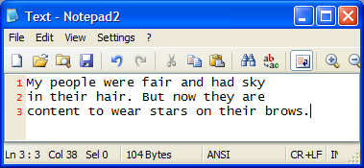
  - the option "Split at paragraphs" creates a new event for every line of the original file:
- the option "Split at non-word characters" creates a new event for every row of alphabetic signs (i.e. for every word) of the original file:

- The option "Split at regular expression" allows the input of any desired expression, according to which text will be distributed into the events. For instance, the expression [\.\?] for the text above would deliver the following result:

10. Tree Tagger Output: imports a text file that contains Part-Of-Speech-Annotation, hence a word per line, as well as separated by tabs according to the Tree Tagger format (http://www.ims.uni-stuttgart.de/projekte/corplex/TreeTagger/) i.e.:

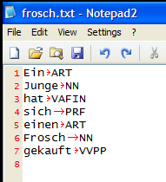

The data will be imported into two or three tiers (depending on whether the initial file only contains POS-Tags, or lemmas as well). One tier is used for the text (the words), the second for the annotation (the POS-Tags) and, if necessary, a tier for lemmas. The tiers will be assigned to a dummy speaker "X". Every word is placed in a separate event:

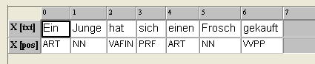

11. TEI file: imports a transcription that is coded according to the guidelines of the Text Encoding Initiative (TEI) in XML (see Schmidt, Th. 2005: Time based data models and the TEI Guidelines for Transcriptions of Speech. Arbeiten zur Mehrsprachigkeit, Serie B.). Select the transcription to be imported and click "Open". After the conversion, a "Cleanup-Dialogue“ will allow you to clean the transcription up according to certain criteria (see "Transcription > Cleanup...“). Thereafter, the transcription will appear as a musical score in the editor.

12. Import via XSL stylesheet: imports an XML file in any desired format by applying a suitable XSL stylesheet that transforms the original format into an EXMARaLDA basic transcription. After selecting the file to be imported, you will be asked to specify such an XSL stylesheet:

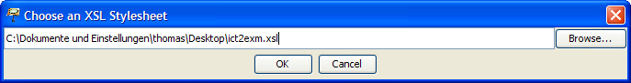

The name of the stylesheet will be saved for the next import.

13. HIAT-DOS file: "imports" HIAT-DOS files. Please note that the quotation marks around the word "import" are supposed to raise awareness to an important circumstance:
- In essence, it is not possible to find a perfect EXMARaLDA correspondence for a given HIAT-DOS date. The "import" function only supplies a rough version that normally needs to be edited manually afterwards.
- The function was developed for HIAT-DOS files at the Special Research Centre on Multilingualism of the University of Hamburg. This explains the replacement rules for Scandinavian special characters, for example. The HIAT-DOS files created at the Special Research Centre neither work with intonation tiers, nor with underlining. Therefore, we have no experience as to what happens to these elements when "imported".

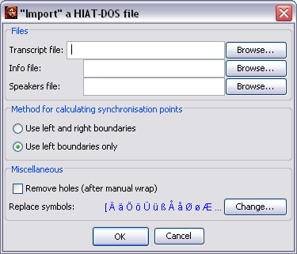

In order to "import" a HIAT-DOS file, fill in the following field:
- Transcript file: This is the file with the actual transcription text. Normally, HIAT-DOS gives these files the file ending ".dat“. Click Browse... to look for the file with the file dialogue. (Hint: The "import“ result is a lot better, when using HIAT-DOS files that do not contain line breaks yet.
- Info file: This is the file that contains information from the transcription head. Normally, HIAT-DOS gives these files the file ending ".inf“. Click Browse... to look for the file with the file dialogue. Even if no file is selected, the "import" can be carried out –the transcription header will simply remain blank.
- Speakers file: This is the file that contains the names of the speakers. Normally, HIAT-DOS gives these files the file ending ".sig“. Click Browse... to look for the file with the file dialogue. Even if no file is selected, the "import" can be carried out – the speaker table will be generated automatically, speaker abbreviations and names can be added afterwards in the Partitur-Editor.
- Method for calculating synchronisation points: When calculating the synchronisation points, either only the left, or both the left and the right boundaries of entries in the HIAT-DOS tiers can be used. Reliable synchronisation points are mostly the left boundaries. However, adding the right tiers may minimise the editing effort afterwards.
- Remove holes (after manual wrap): This (time consuming) method is recommended if you would like to "import" a HIAT-DOS file with an afterwards edited line break.
- Replace symbols: HIAT-DOS uses a non ANSI compliant coding method for German special characters. These signs are replaced by default (as well as some replacement signs for Scandinavian special characters). If you would like to change the characters that should be replaced, click Change... , to get the following dialogue:

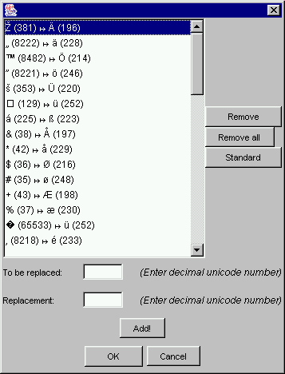

This list contains all replacements, as glyph, followed by the corresponding Unicode number. In order to delete a single replacement, select it in the list and click Remove. In order to delete the entire list, click Remove all. To only replace the German special characters and "ß", click Standard. In order to add a replacement, enter the decimal Unicode into the fields "To be replaced“ and "Replacement“ and click Add!. Exit the dialogue with OK, to save the changes.

14. ExSync file: imports files that are syncWRITER output ("ExSync Data) (The exact functionality is listed in the document Leitfaden für die Konvertierung von Legacy Data).

15. CHAT Transcript: imports files that have been created with the CLAN Editor of the CHILDES System.

16. Phon transcription: imports files that have been created with the Phon Editor of the
Phonbank-System.

File > Export
Opens a window for the export in different formats. The drop-down list “Save as type” offers different formats:

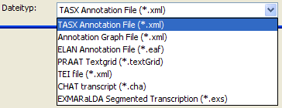

1. TASX Annotation File: The exported file can be opened and edited in the TASX-Annotator. Please note that such an export is only useful, if at least some of the points on the time axis have been equipped with absolute time values (non-existing times will be interpolated).

2. Annotation Graph File: exports the current transcription into the Atlas Interchange-Format, Level 0. The format can be used as an exchange format with a number of other tools (ANVIL, Transformer, MAVVissta, etc.). For this, see:

Th. Schmidt, S. Duncan, O. Ehmer, J. Hoyt, M. Kipp, D. Loehr, M. Magnusson, T. Rose & H. Sloetjes (2008): An exchange format for multimodal annotations. In: Proceedings of the Language Resource and Evaluation Conference 2008, Marrakech, Paris: ELRA.

ELAN Annotation File: The exported file can be opened and edited in the TASX-Annotator. Please note that such an export is only useful, if at least some of the points on the time axis have been equipped with absolute time values (non-existing times will be interpolated). Furthermore, you should have specified the underlying media file (see „Transcription > Recordings...“).

4. FOLKER Transcription: exports the current transcription into the format of the FOLKER Editor. Take note that for every speaker only the first tier of type 'T(ranscription)' will be taken into account. Contents of annotation and description tiers will thus be lost during export.

5. PRAAT Textgrid: The exported file can be opened and edited in Praat. Please note that such an export is only useful if at least some of the points on the time axis have been equipped with absolute time values (non-existing times will be interpolated).

6. TEI file: exports a file that is coded according to the specifications of the Text Encoding Initiative (TEI) in XML. Different export options are offered:
- Generic: In this option, a TEI-file is created that transfers the text events without alterations. This is the most basic form of exporting. It results in practical data for most results.
- Based on Modena method: This option is used in a project at the University of Modena. Requirement for a practical result is the compliance with the conventions in reference to the event text.
- Based on AZM method: see Schmidt, Th. 2005: Time based data models and the TEI Guidelines for Transcriptions of Speech. Arbeiten zur Mehrsprachigkeit, Serie B.
- Based on HIAT segmentation: this variation contains the TEI-Document mark-up for units of the HIAT-System (words, pauses, non-phonological items, utterances etc.). The export requires a successful segmentation according to HIAT. If the segmentation fails, an error message will appear.

8. CHAT transcript: exports a file in the CHAT-format that can be opened with the CLAN-Editor of the CHILDES-System.

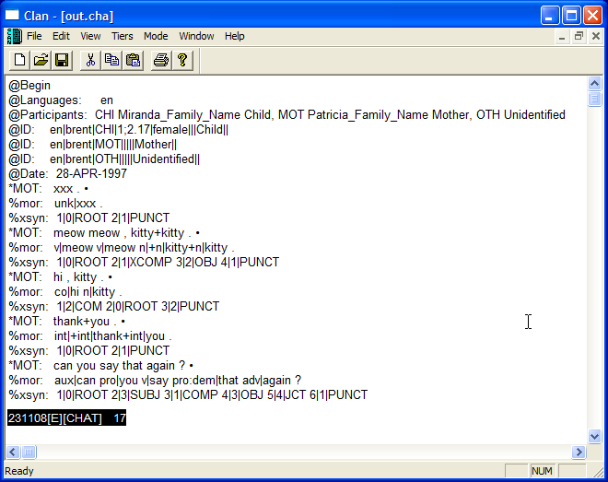

Different variants are offered:
- Based on CHAT segmentation: The requirement for this type of output is that the transcription can be segmented with the CHAT algorithm, i.e. the CHAT transcription symbols have been used according to the convention (see also Appendix B: Segmentation Algorithms). If segmentation errors have been made, an error message will appear and no output file will be created.
- Based on HIAT segmentation: The requirement for this type of output is that the transcription can be segmented with the HIAT algorithm, i.e. the HIAT transcription symbols have been used according to the convention (see also Appendix B: Segmentation Algorithms). If segmentation errors have been made, an error message will appear and no output file will be created.
- Based on events: This option does not use a segmentation algorithm, but single events in tiers of type T(ranscription) are transformed into CHAT utterances.

9. Audacity Label File: exports a text file that can be read by the Audi-Editor in Audacity.

10. EXMARaLDA Segmented Transcription: The exported file can be integrated into an EXMARaLDA corpus and browsed with EXAKT. Contrary to "Transcription > Export Segmented Transcription..." no segmentation algorithm is used here.

File > Exit
Closes the current transcription and exits the Partitur-Editor. If the changes have not been saved, you will be asked whether you would like to save the changes.

